**Student Result Processing System – SQL Server Project**

**Tool: SQL Server (Microsoft SQL Server Management Studio - SSMS)**

**Step 1: Create Database and Tables**

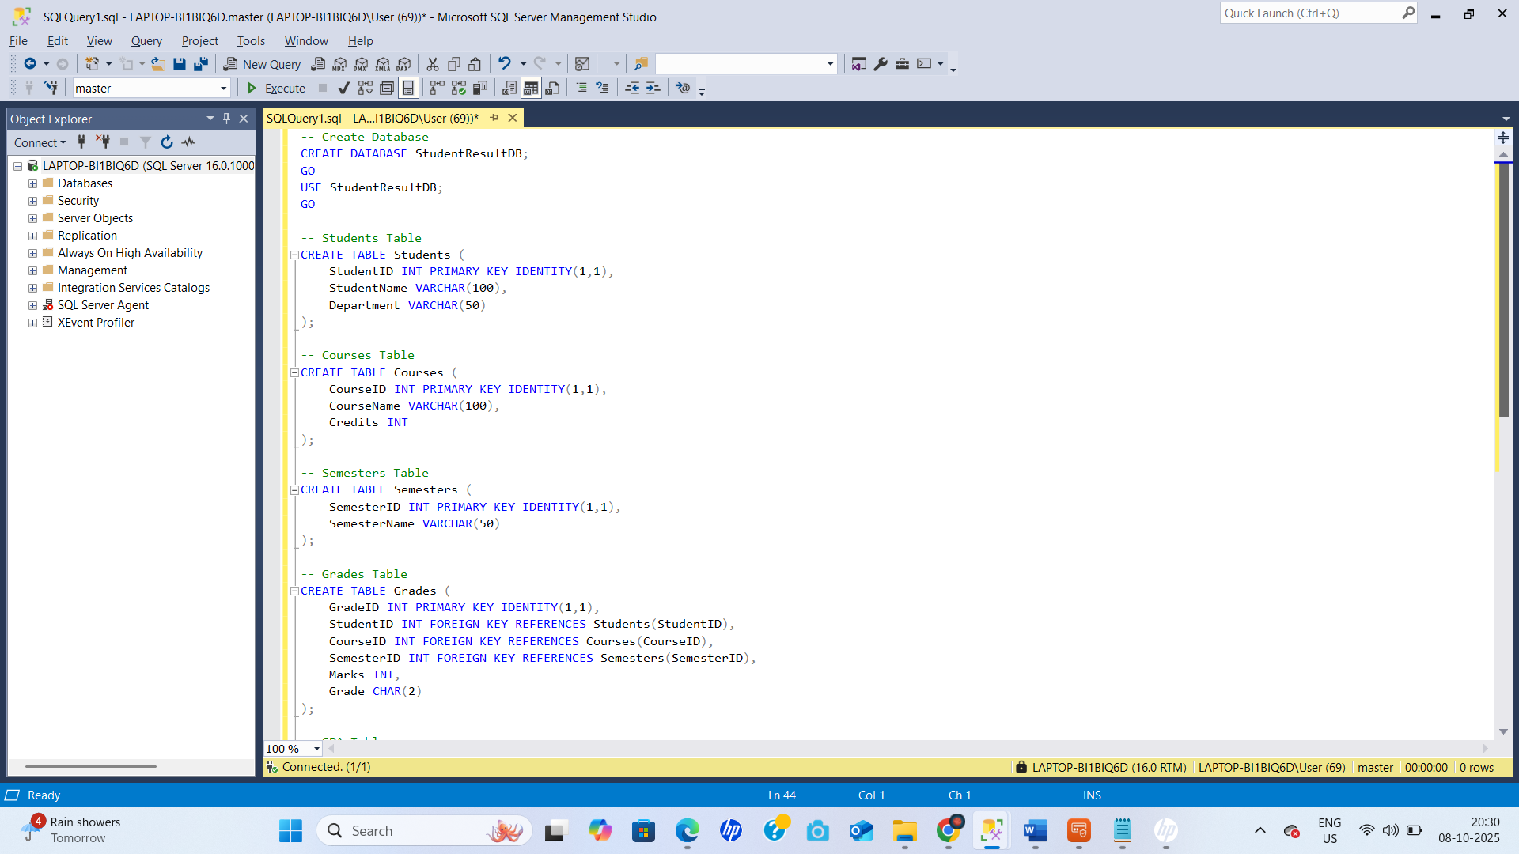

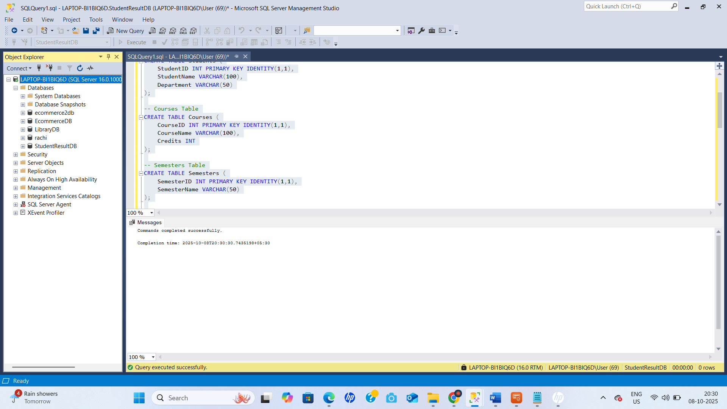

**Step 2: Insert Sample Data**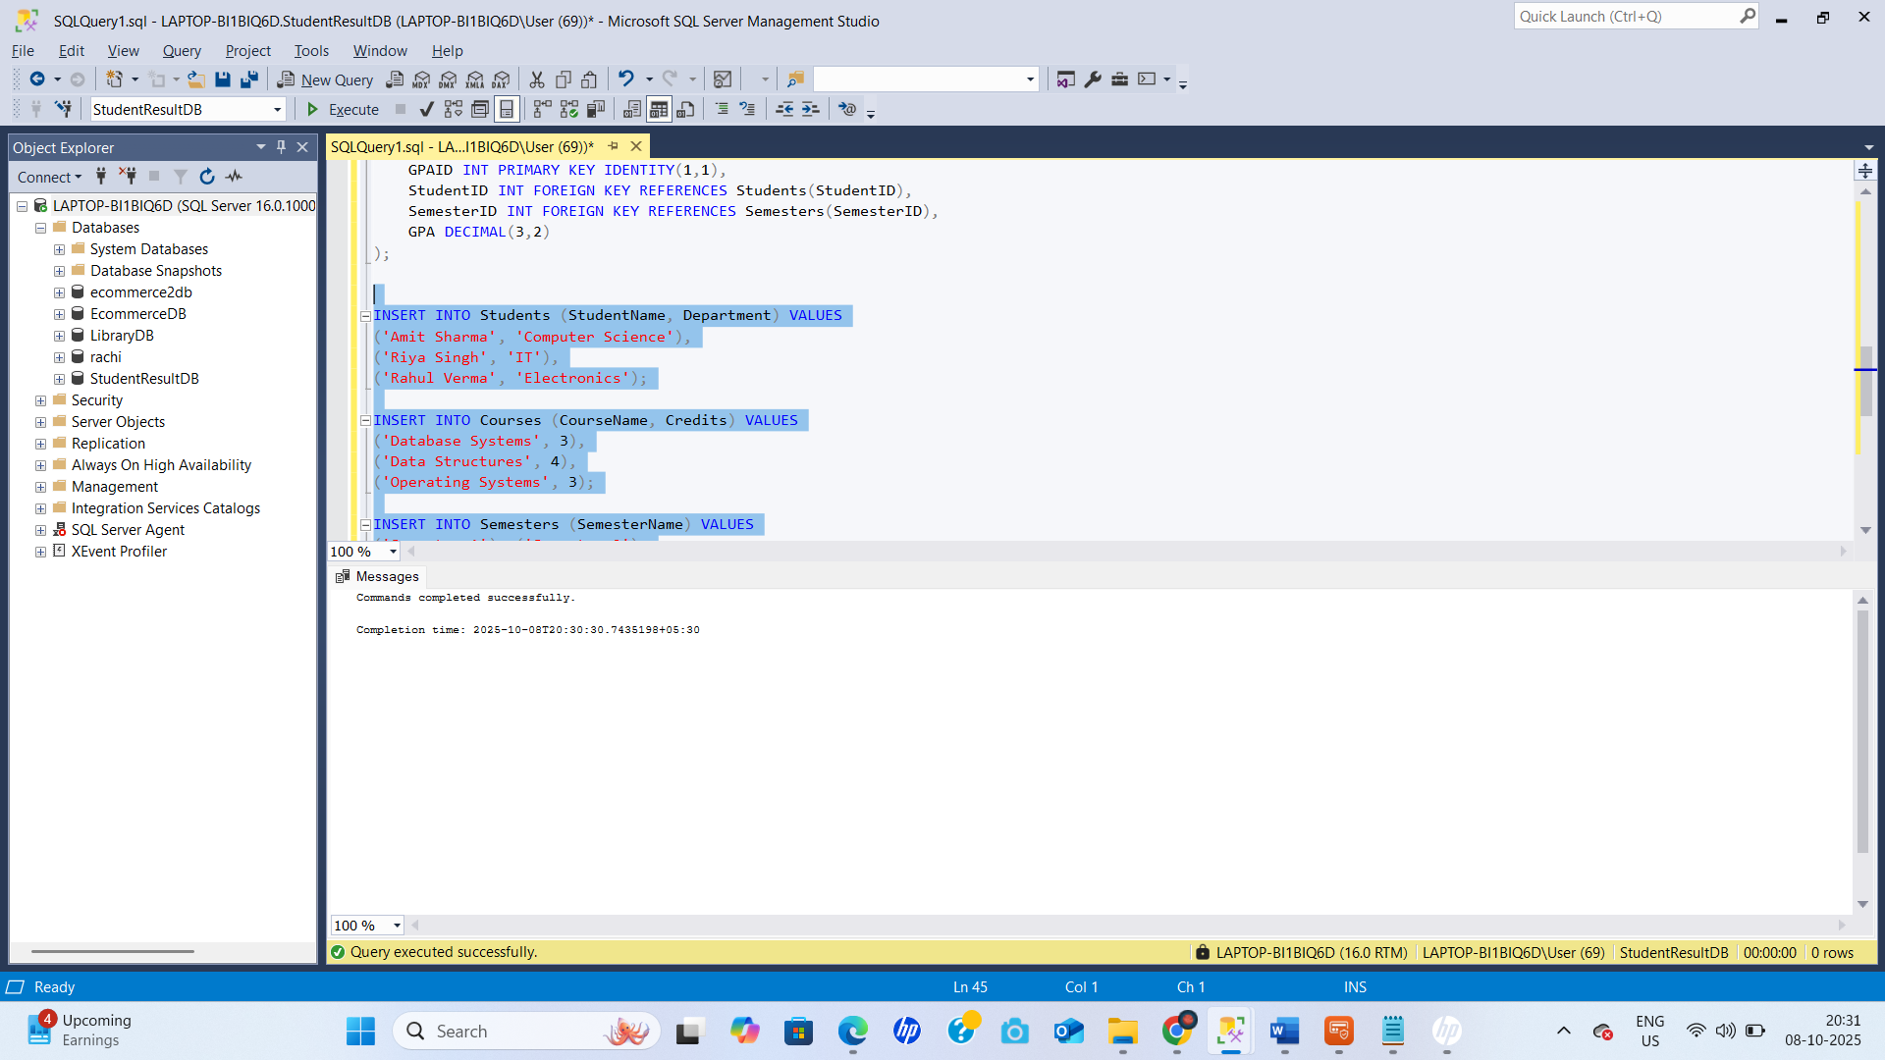

**Step 3: Trigger to Calculate GPA Automatically**

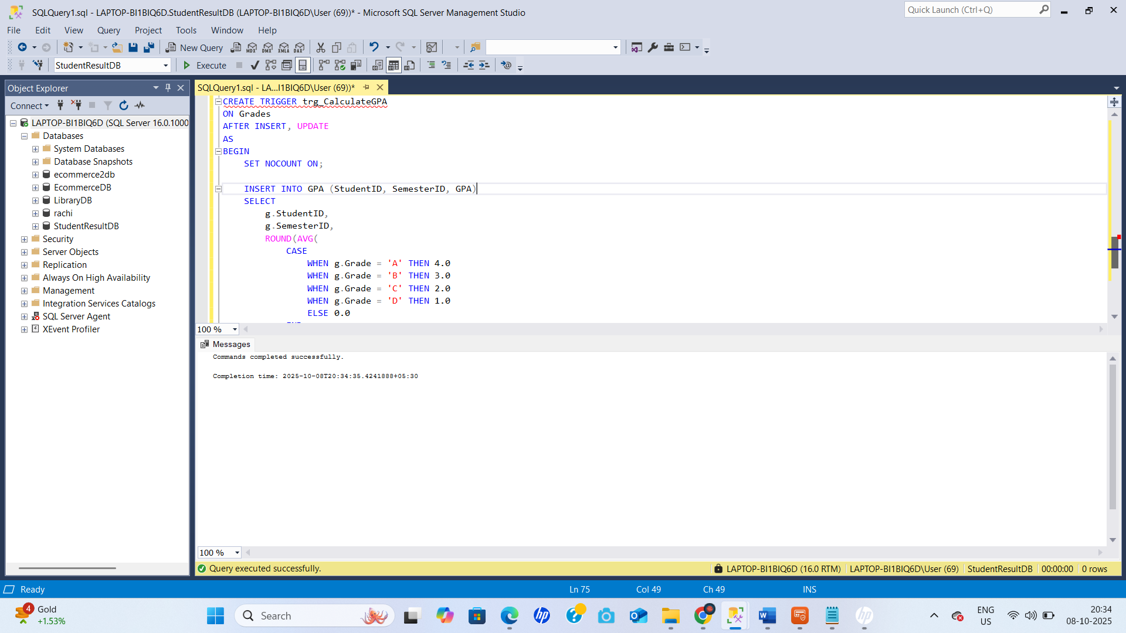

Step 4: Queries for Reports

1. Semester-wise GPA Report

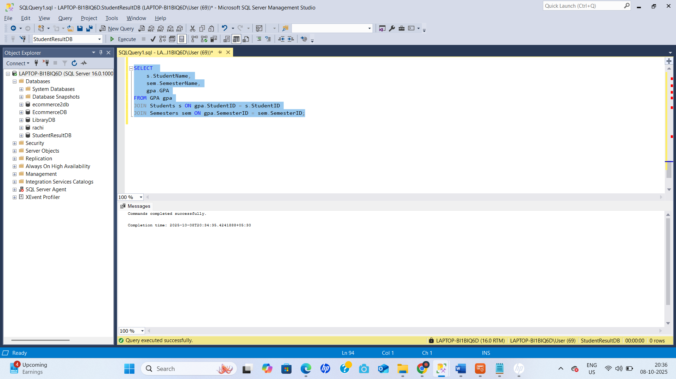

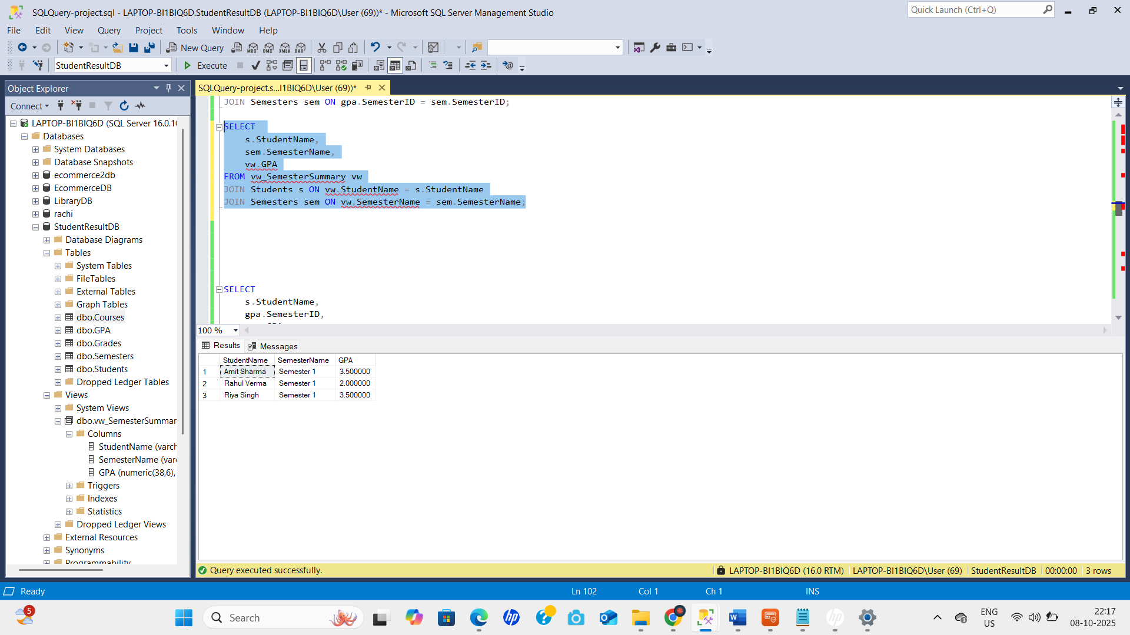

1. Rank List (Using Window Function)

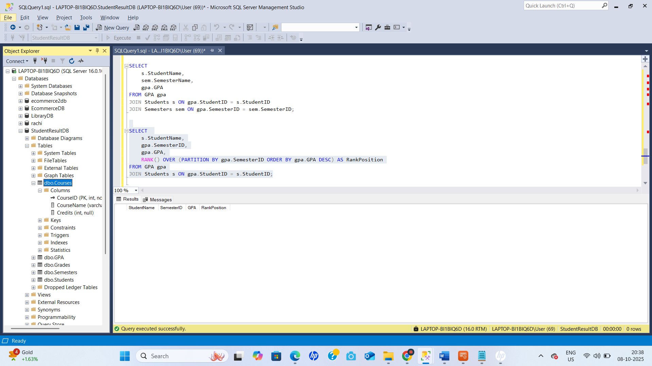

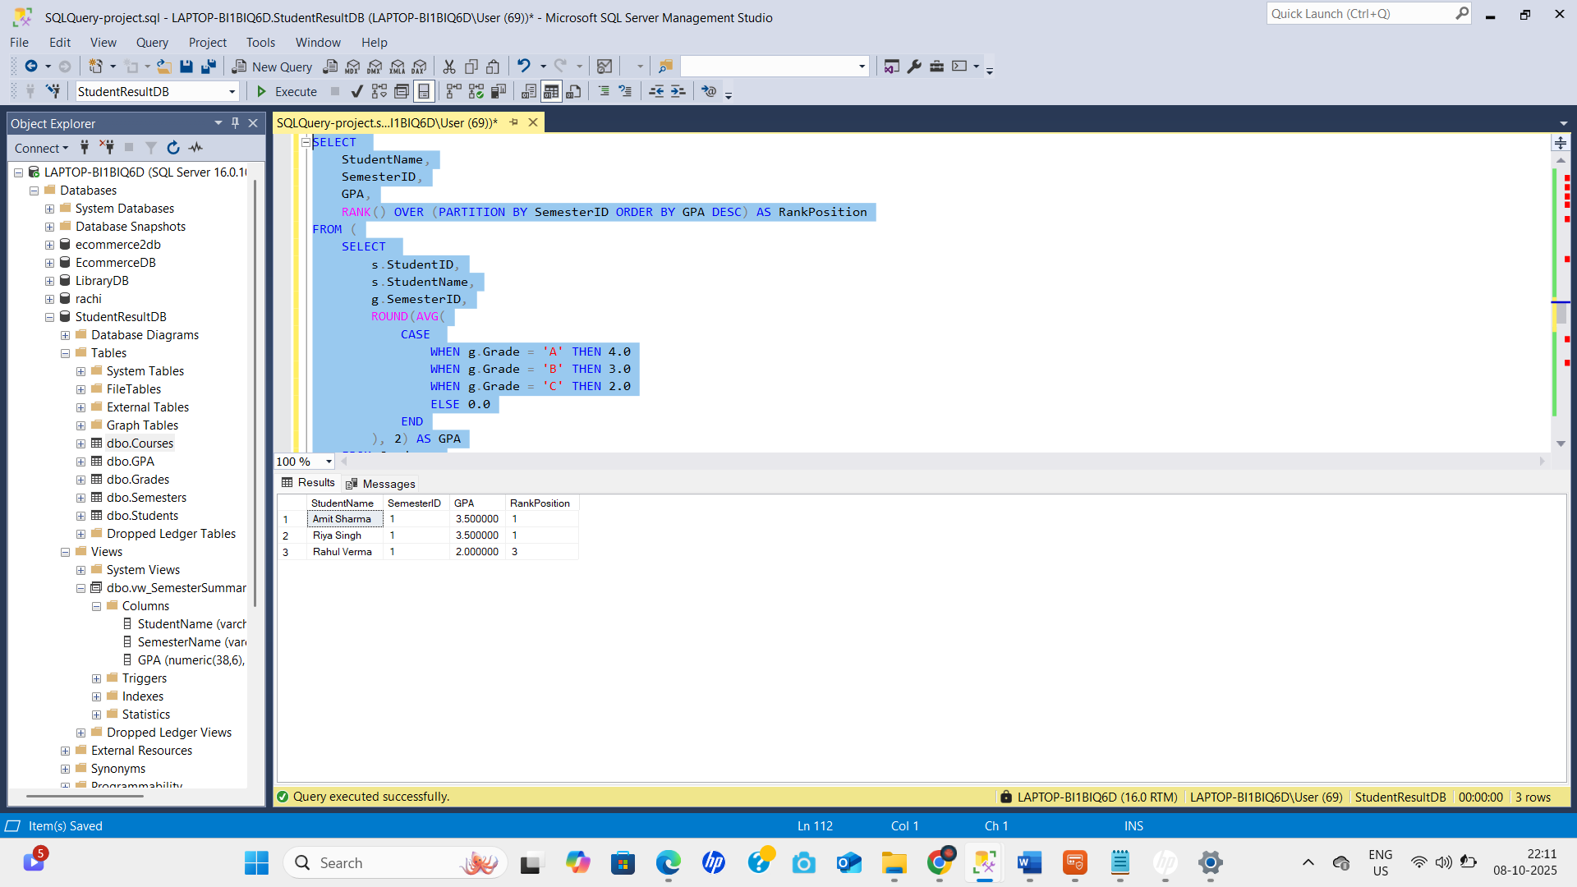

1. Pass/Fail Report

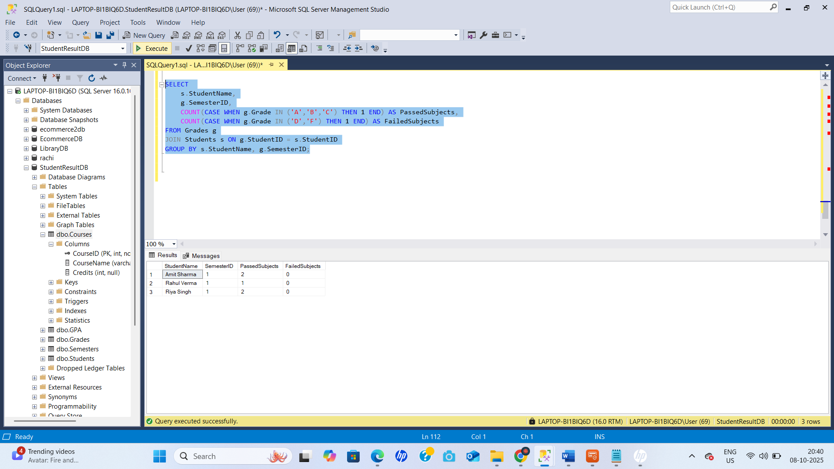

Step 5: View for Summary Report

